Microsoft Office 365 Explained
Allows users to use Microsoft Office suite (Word, Excel, Outlook, One Note, One Drive, etc.) anytime/anywhere (think 365 days in a year)
Office 365 Video

Login to Office 365 and Install Outlook App on phone DIRECTIONS
(Students email teachers/students and when you email them back, their phone buzzes stating they have an email from you)
*Skipping the first 6 steps will result in the app not working*
- Do NOT install the app first
- Open a web browser go to https://login.microsoftonline.com/ (computer/phone/tablet/etc.)
- Username: firstname.lastname@cvs.k12.mi.us
- Password: same password used to log into CVS computers
- If that doesn't work, try yourstudentnumber@cvs.k12.mi.us and your password will be the same as you log into the school computers
- Still doesn’t work then teacher should put in a helpdesk ticket
- Select EASTERN TIME ZONE
- Hit Ok
- Go to your APP STORE
- Download Microsoft Outlook
- Click the RED OFFICE 365 App
- Enter same username and password from above step
*Teacher can look up what a student’s username is by opening a blank email, click the TO: button
Then type the student’s last name and see what their email/username is

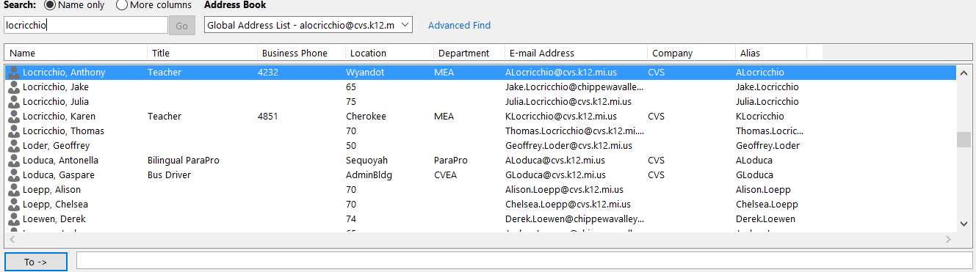

How to Log into MS Office 365 Video
Videos found on Locricchio’s website (alocricchio.weebly.com) click tutorials, scroll down to the third video.
Everyone knows that Office 365 doesn’t have as many functions or bells and whistles as our Office 2013 on our computers. How about combining the bests of both worlds?
TEACHERS
How to save to One Drive from MS Office 2013 (version installed on CVS Computers)
- Press File
- Save As
- Click ONE DRIVE Chippewa Valley Schools
- Click Current Folder, OneDrive – Chippewa Valley Schools
- Now you’ve saved your document in One Drive and it’s automatically saving; see the green arrows on the save button?

STUDENTS
Students can do the same thing but since their computers are virtualized, they’ll have to do the next steps each time they log into CVS computers.
- Create document/Power Point/Excel/etc. in MS Office 2013
- Press File
- Click Save As
- Now the students have to add their One Drive location
- Click Add Place
- Click One Drive
- Student now has to add the location to their One Drive
- Have them enter their username/email address to log into OFFICE 365; it’s firstname.lastname@cvs.k12.mi.us and their same password they use to log into CVS computers
- If that doesn't work, try yourstudentnumber@cvs.k12.mi.us and your password will be the same as you log into the school computers
- Still doesn’t work then teacher should put in a helpdesk ticket

How about creating a doc. In Office 365, but then opening in Office 2013 (on our CVS computers) so you get all the functions of Office but with the Office 365 function of automatically saving to One Drive?
- Start a doc. In Office 365
- Click the little ‘waffle’
- Click on the type of ‘app’ (Excel, Word, Power Point, etc.) you want
- Next close the doc.
- Reopen the document but now click Edit in Word
- Now your document is open in the desktop version of MS Office 2013 (version on our CVS computers) but now it automatically saves to One Drive

Uploading entire folders to our Office 365 ONE DRIVE
- Log into Office 365 using Internet Explorer (IE), won’t work in Google Chrome
- Make sure you check the box to Keep Me Signed in; if you don’t it won’t allow you to drag and drop folders from your h drive to your One Drive.
- Click on the waffle
- You need to add the ribbon
- Click the gear or sprocket
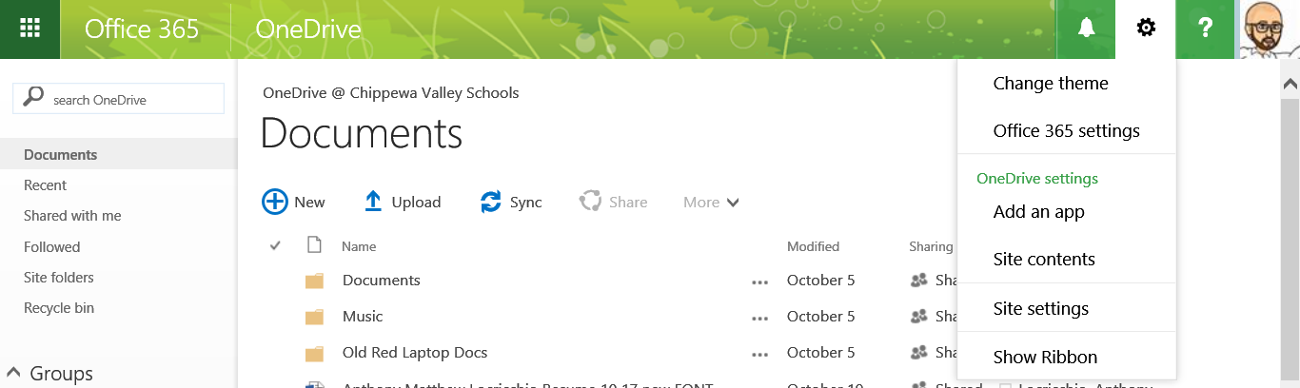
- Click Show Ribbon

- Click library
- Now click on Open in Explorer

- Now you can drag and drop entire folders into your One Drive
- Open your H Drive and locate the folder(s) you want uploaded to your One Drive
- Pull that folder to the left so it “Snaps” to the left
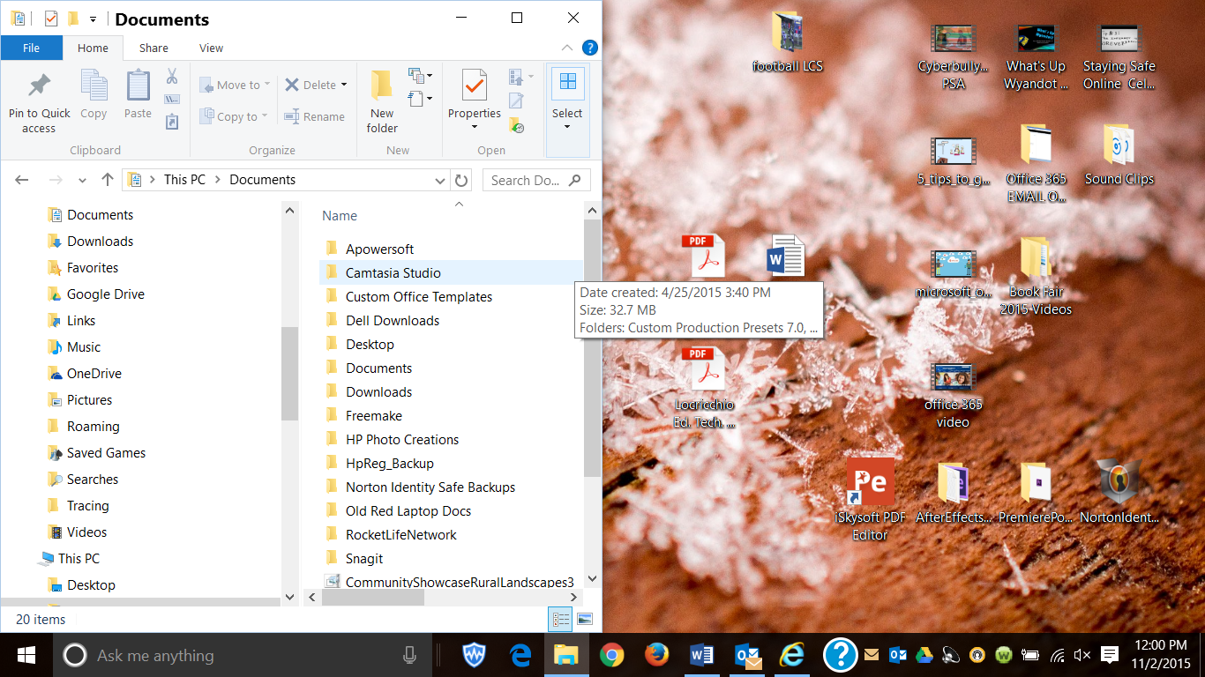
- Now open your ONE Drive Folder on the right so you can drag and drop your H Drive folders (on left) to your One Drive (on right)
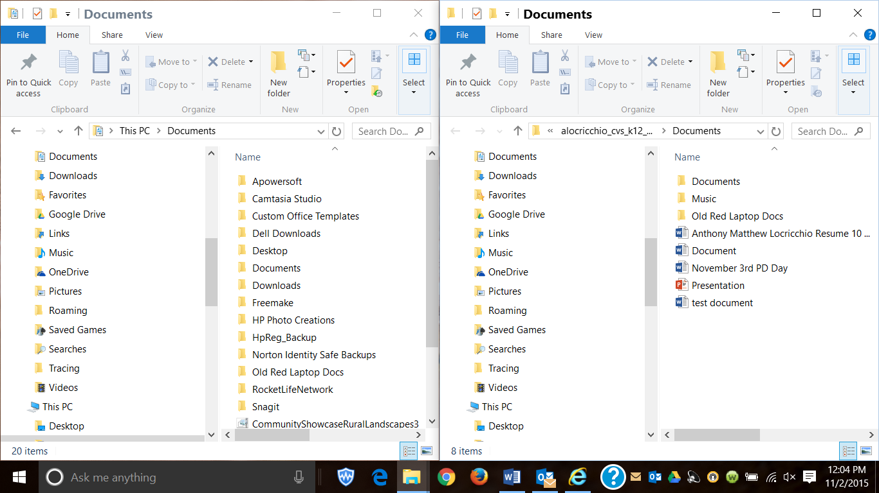
- Notice the folder on the right says documents but look where it says _cvs_k12_...that is your One Drive

- Now you can drag and drop folders from whatever is on your computer to your One Drive

