Name:__________________________________________________Hour:________
Chapter 8
We’ll learn all the compromises that came out of the Constitutional Convention
Directions
It’s 1787 and the Constitutional Convention has officially ended. You and your partner are working for a printing press company and you are both in charge of creating images to educate the citizens on all the important compromises created during the Constitutional Convention. For your images to be effective, there must be VERY limited wording and the pictures must express the answer to each question below.
Directions/Requirements
- Save this document to your ONE DRIVE (tell Mr. Locricchio to show you the video on how to do so). This will allow your document is automatically saving
- Find an image that represents each section below (8.5-8.10)
- Paste that image in the correct section below (8.5-8.10)
  - Use Google CHROME internet browser, NOT internet exploder
  - Click Google IMAGES
  - When you find an image you like, Click VIEW images

  - 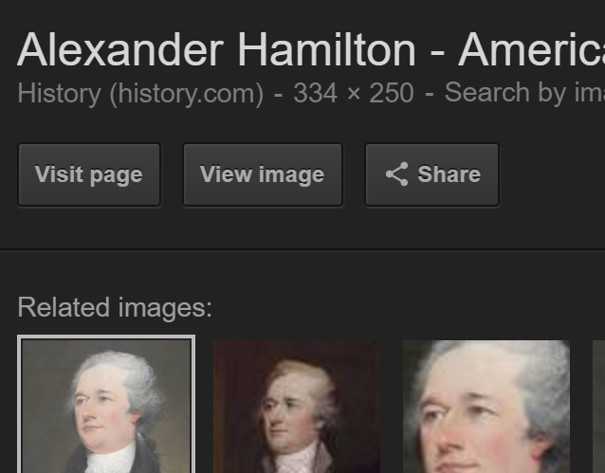

- Next RIGHT click on the image and click SAVE AS

- Save this image to your desktop
- Next insert the image into the correct section
  - To do this, put your cursor where you want your image to be placed.

  - Select the INSERT tab in Word
  - Click pictures, NOT online pictures

  - 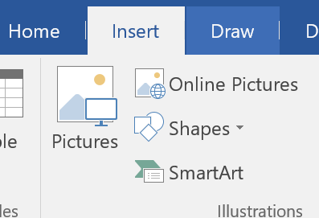

- Insert a text box below each picture
  - Click insert tab in Word
  - Click text box and choose any text box you prefer

  - 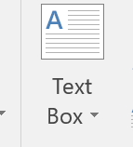

- Type one to two words, NOT sentences, in the textbook below each one of your images that help explain your image(s)
Scroll
Down
To
The
Next
Page

8.5 How Should States Be Represented in the New Government?
Completed by:
VA Plan (watch the video on Locricchio’s website: links: Project Links:Chapter 8)
  - Who proposed the plan?
  - How many houses (NOT branches) were proposed?
  - What would representation be based on in Congress/Legislature? 1 image /question (Five pictures total)
  - Who liked the plan (large or small states)?
  - Why did they (large or small states) like this plan and/or who did it favor?

Completed by:
NJ Plan (watch the video on Locricchio’s website: links: Project Links:Chapter 8)
- Who proposed the plan?
- How many houses (NOT branches) were proposed?
- What would representation be based on in Congress/legislature? 1 image /question (Five pictures total)
- Who liked the plan (large or small states)?
- Why did they (large or small states) like this plan and/or who did it favor?

8.6 Resolution: The Great Compromise
Completed by:
(watch the video on Locricchio’s website: links: Project Links:Chapter 8)
The Great Compromise
  - Who proposed the plan? 1 image
  - Explain the plan/compromise (The Great Compromise)
    - Remember it took something from the VA plan and something from NJ plan
    - What house (not branch) TODAY represents what small states wanted (NJ plan) and which house TODAY represents what larger states (VA plan)? 2 images

Completed by:

8.7 How Should Slaves Be Counted?(This section has NOTHING to do with 3/5’s Compromise, that’s section 8.9)
- How did SLAVE states want slaves to be counted? Why? (Two images)
- How did FREE states want slaves to be counted? Why? (Two images)
- What were Northerners new thoughts on slavery? Six images total
- What were Southerners new thoughts on slavery (hint: economy)?

Completed by:
  - Resolution: Compromises on Slavery
- Explain the Three-Fifths Compromise (Use two images to do this)
- To save the convention, what other compromises on slavery were given?
  - What change(s) were made with Slave Trade (one image) Four images total
  - What change(s) were made with the Fugitive Slave Clause (one image)

Completed by:

8.9 How Should the Chief Executive Be Elected?
- One executive vs. three executives Three images
  - Why did some of the Founding Fathers not want one executive? (One image) total
  - Why did some Founding Fathers want three executives? (One image)

Completed by:

8.9 How Should the Chief Executive Be Elected? Continued
- Choosing the Chief Executive
  - What were the three options for choosing the chief executive?
    - Option #1 (one image) Three images total
    - Option #2 (one image)
    - Option #3 (one image)

Completed by:
8:10 Resolution: The Electoral College
- The compromise for choosing the chief executive was the Electoral College. How does today's Electoral College system differ from the one the Founding Fathers created?
  - The first three images (Founding Fathers’ Electoral College)
3 images total
    - People ______ _______ pick their president
    - 2nd place became _____________
    - No ____________ parties
  - The next three images (Today’s Electoral College)
    - When people vote today, they are voting twice. The Popular vote and then the ______________ vote
3 images total
    - The presidential candidate picks his/her __________________president.
    - Today there are ________________ parties.

Chapter 8 Project Rubric
Partner #1:____________________________Sections Completed:______________________
Criteria | Points 10-9 | Points 8-7 | Points 6-5 | Points 4-0
Effort | It’s evident there was eighth grade quality effort | There was a good deal amount of effort put forward | The group could have but forth more effort | Every little effort was put forth
Pictures | Pictures are related to the topic and are thoughtfully chosen  Must have the required amount of credible pictures (include URL) | Pictures are related to the topic and are of good quality | Pictures are related to the topic, and are of good quality. | Pictures seem randomly chosen, are of low quality, OR distract the reader.
Conventions | There are no errors in spelling, punctuation or grammar. | There are 1-3 errors in spelling, punctuation or grammar. | There are 4-5 errors in spelling, punctuation or grammar. | There are more than 5 errors in spelling, punctuation or grammar.
Content Accuracy | All information is accurate and all the requirements of the assignment have been met. The information is in chronological order | Almost all the information is accurate and all requirements of the assignment have been met. | Almost all of the information is accurate and almost all of the requirements have been met. | There are several inaccuracies in the content provided by the students OR many of the requirements were not met.
Aesthetics | The posters are pleasing to the eye; (same font is used throughout the page, all font is in black, titles are underlined, etc.) the items are symmetrical and there is very little BLANK space. | A majority of the site is pleasing to the eye; most items are symmetrical and there is very little white space. | Some of the site is pleasing to the eye; some items are symmetrical and there is some white space. | Very little, if any, of the site is pleasing to the eye; very little, if any of the items are symmetrical, there is a lot of white space.
Message | The overall message for all the posters are easily understood. | Many the messages for the posters are easily understood. | A few of the messages are difficult to understand | Many of the messages are difficult to understand

Total Score:_________/60 (Remember, all projects are worth 90% of your grade!)
Comments:
Partner #2:____________________________Sections Completed:______________________
Criteria | Points 10-9 | Points 8-7 | Points 6-5 | Points 4-0
Effort | It’s evident there was eighth grade quality effort | There was a good deal amount of effort put forward | The group could have but forth more effort | Every little effort was put forth
Pictures | Pictures are related to the topic and are thoughtfully chosen  Must have the required amount of credible pictures (include URL) | Pictures are related to the topic and are of good quality | Pictures are related to the topic, and are of good quality. | Pictures seem randomly chosen, are of low quality, OR distract the reader.
Conventions | There are no errors in spelling, punctuation or grammar. | There are 1-3 errors in spelling, punctuation or grammar. | There are 4-5 errors in spelling, punctuation or grammar. | There are more than 5 errors in spelling, punctuation or grammar.
Content Accuracy | All information is accurate and all the requirements of the assignment have been met. The information is in chronological order | Almost all the information is accurate and all requirements of the assignment have been met. | Almost all of the information is accurate and almost all of the requirements have been met. | There are several inaccuracies in the content provided by the students OR many of the requirements were not met.
Aesthetics | The posters are pleasing to the eye; (same font is used throughout the page, all font is in black, titles are underlined, etc.) the items are symmetrical and there is very little BLANK space. | A majority of the site is pleasing to the eye; most items are symmetrical and there is very little white space. | Some of the site is pleasing to the eye; some items are symmetrical and there is some white space. | Very little, if any, of the site is pleasing to the eye; very little, if any of the items are symmetrical, there is a lot of white space.
Message | The overall message for all the posters are easily understood. | Many the messages for the posters are easily understood. | A few of the messages are difficult to understand | Many of the messages are difficult to understand
Total Score:_________/60 (Remember, all projects are worth 90% of your grade!)
Comments:

Example
What parts make up the First Amendment?
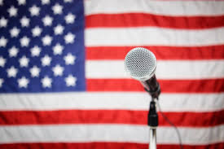
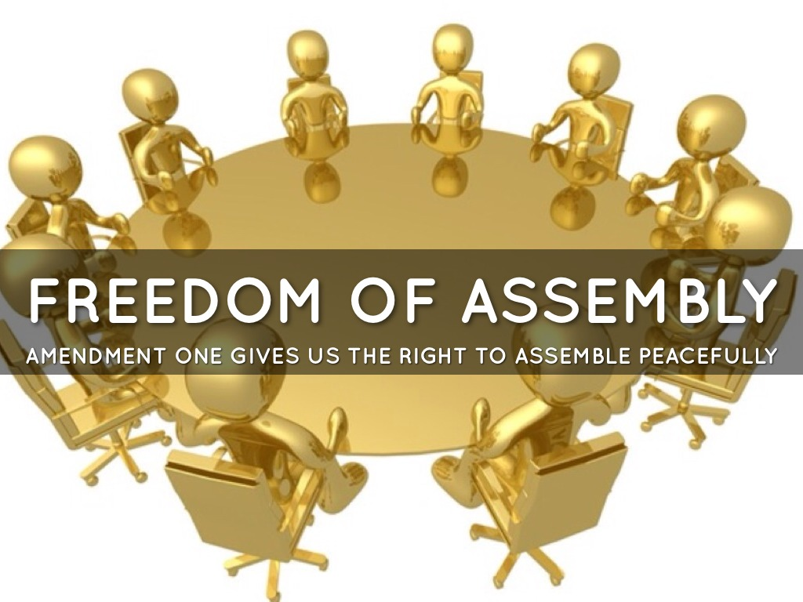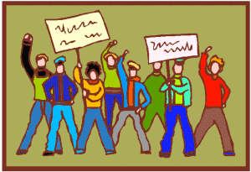
- Speech
https://745515a37222097b0902-74ef300a2b2b2d9e236c9459912aaf20.ssl.cf2.rackcdn.com/953fb0eb928c158c9ae400b02520f555.jpeg
2. Religion
http://www.freedoms.com/religions
3. Press
http://www.hippoquotes.com/img/freedomofpressaquotes/freetoassemble2.jpg
4. Assemble
http://www-tc.pbskids.org/arthur/i/games/fo_splash.gif
5. Petition
http://www.usconstitution.net/gifs/kids/c4_protest.gif

